European  curriculum vitae  format   |  |  | 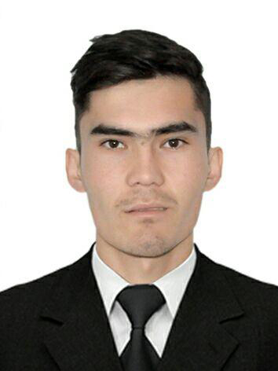
Personal information
Name |  | Botirov Nodirjon Rustam o’g’li
Home Address |  | Samarkand Region Urgut. Mirzaqishloq Joziba street. Home 35.
Telephone |  | +998937214129
E-mail |  | unknownnod@gmail.com
Nationality |  | Uzbekistan
Date of birth |  | 10.09.1998
Passport |  | AB0270464, State personalization centre Urgut region, Uzbekistan
Sphere of scientific interests |  | Web development
Work experience
• Dates (January 2019 until now)
• Name and address of employer |  | Samarkand branch of Tashkent university of information technologies named after Muhammad al –Khwarizmi, Samarkand 100202 Uzbekistan
• Type of business or sector |  | Information technology center
• Occupation or position held |  | Information Systems Implementation Unit, Software Engineer
• Main activities and responsibilities |  | Control system, manage support software and hardware of Computers
Education and training
• Dates (Semptember 2017 until now)
• Name and type of organization providing education and training |  | Samarkand branch of Tashkent university of information technologies named after Muhammad al –Khwarizmi, Uzbekistan (Bachelors)
• Principal subjects/occupational  skills covered |  | Software Engineering
Personal skills
and competences
Mother tongue |  | Uzbek
Other languages |  | Russian
• Reading skills |  | excellent
• Writing skills |  | good
• Verbal skills |  | good
Other languages |  | English
• Reading skills |  | excellent
• Writing skills |  | excellent
• Verbal skills |  | excellent
Social skills  and competences |  | Excellent ability of communication and ability to attract attention
Organisational skills  and competences |  | Good capacity to coordinate and implement complicated projects proved by numerous responsibilities held
Technical skills  and competences  With computers, specific kinds of equipment, machinery, etc. |  | Excellent ability in navigate through the Internet  Excellent knowledge of Computer systems and networks  Excellent knowledge in web develeopment, databases.  Good knowledge in programming languages: C/C++,PHP, Javascript, YII2 Framework, MYSQL.
Marital status |  | Unmarried

